INFORMATION MANAGEMENT
EXERCISE 3
1. List all employees whose last names begin with P.
SELECT f_name, l_name FROM employee_data WHERE l_name LIKE 'P%';
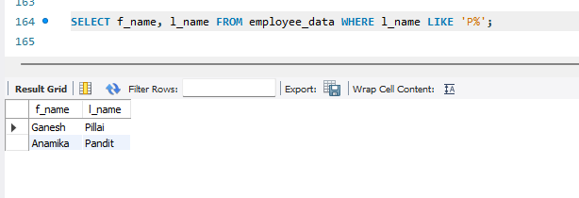
2. Display the names of all employees in the marketing division.
SELECT f_name, l_name FROM employee_data WHERE title LIKE '%Marketing%';
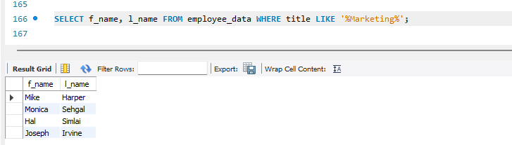
3. What will the following statement display?
SELECT f_name, l_name, salary FROM employee_data WHERE f_name LIKE '%k%';
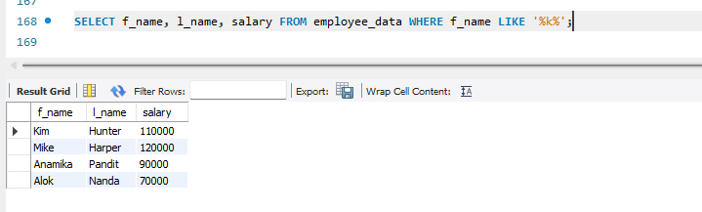
4. List the last names and titles of all programmers.
SELECT l_name, title FROM employee_data WHERE title LIKE '%Programmer%';
